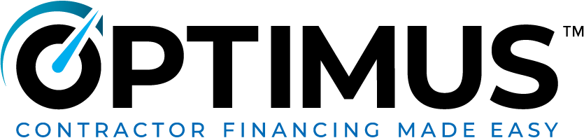
[Company Logo]

Payment Options Waiver

I acknowledge that the payment options for my project, including but not limited to those listed below, have been discussed with me. I decline to move forward with the process to secure any of these options and understand that they may no longer be available to me upon completion of my project.

Payment Options:

- 10.99%/15 year - low monthly payment
- 9.99%/10 year - low monthly payment
- 18 month No interest With payment
- 12 month No interest No payment

X___________________ X___________________
Applicant Co-Applicant

